SMIT R PATEL

19162121031

SEM 5

BIG DATA AND ANALYTICS

PRACTICAL 1

1. You are a student who is comfortable working with Linux. With the following in mind, simply try out the LS command to list all the files and directories as you would do in a Linux system. Now, try the following for listing files and directories in a Hadoop system with “hadoop fs -ls”

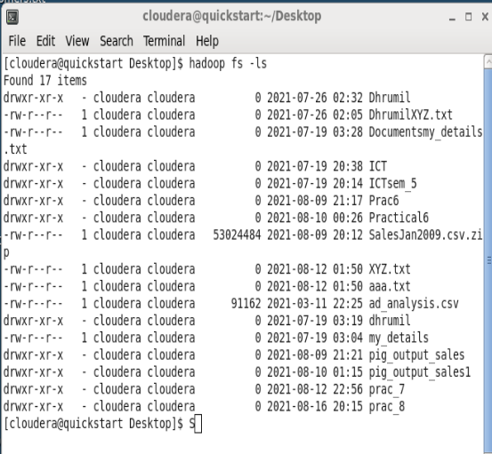

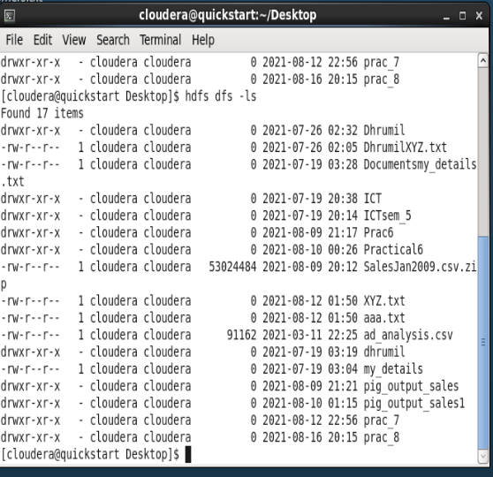

2 You are now aware you cannot change directories in Hadoop . Hence, create a folder on your Hadoop home directory with your name.

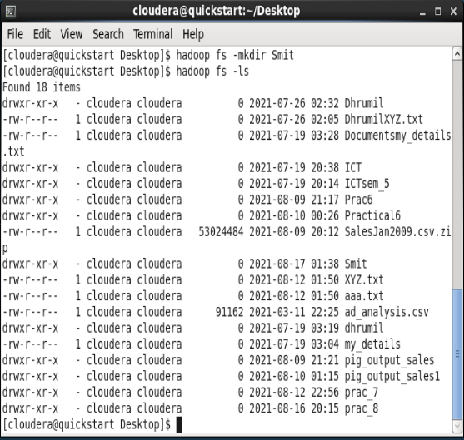

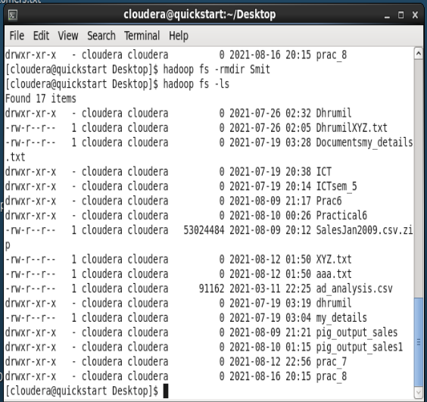

1. Create an empty file in your Hadoop system using the touchz command.

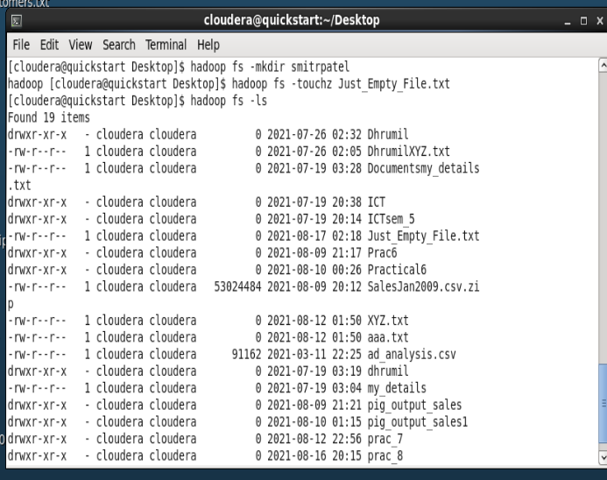

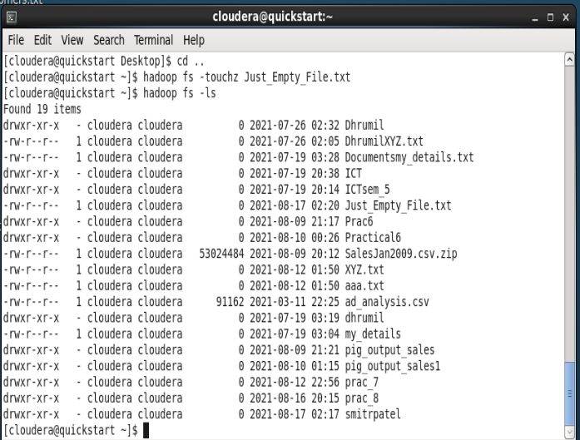

4. Create a sample file in your LOCAL SYSTEM and name it- ABC, and execute the “copyFromLocal”

command in your Hadoop system to copy this file to the folder you created in your name.

